Jira Integration
UserStory fetched from Jira:
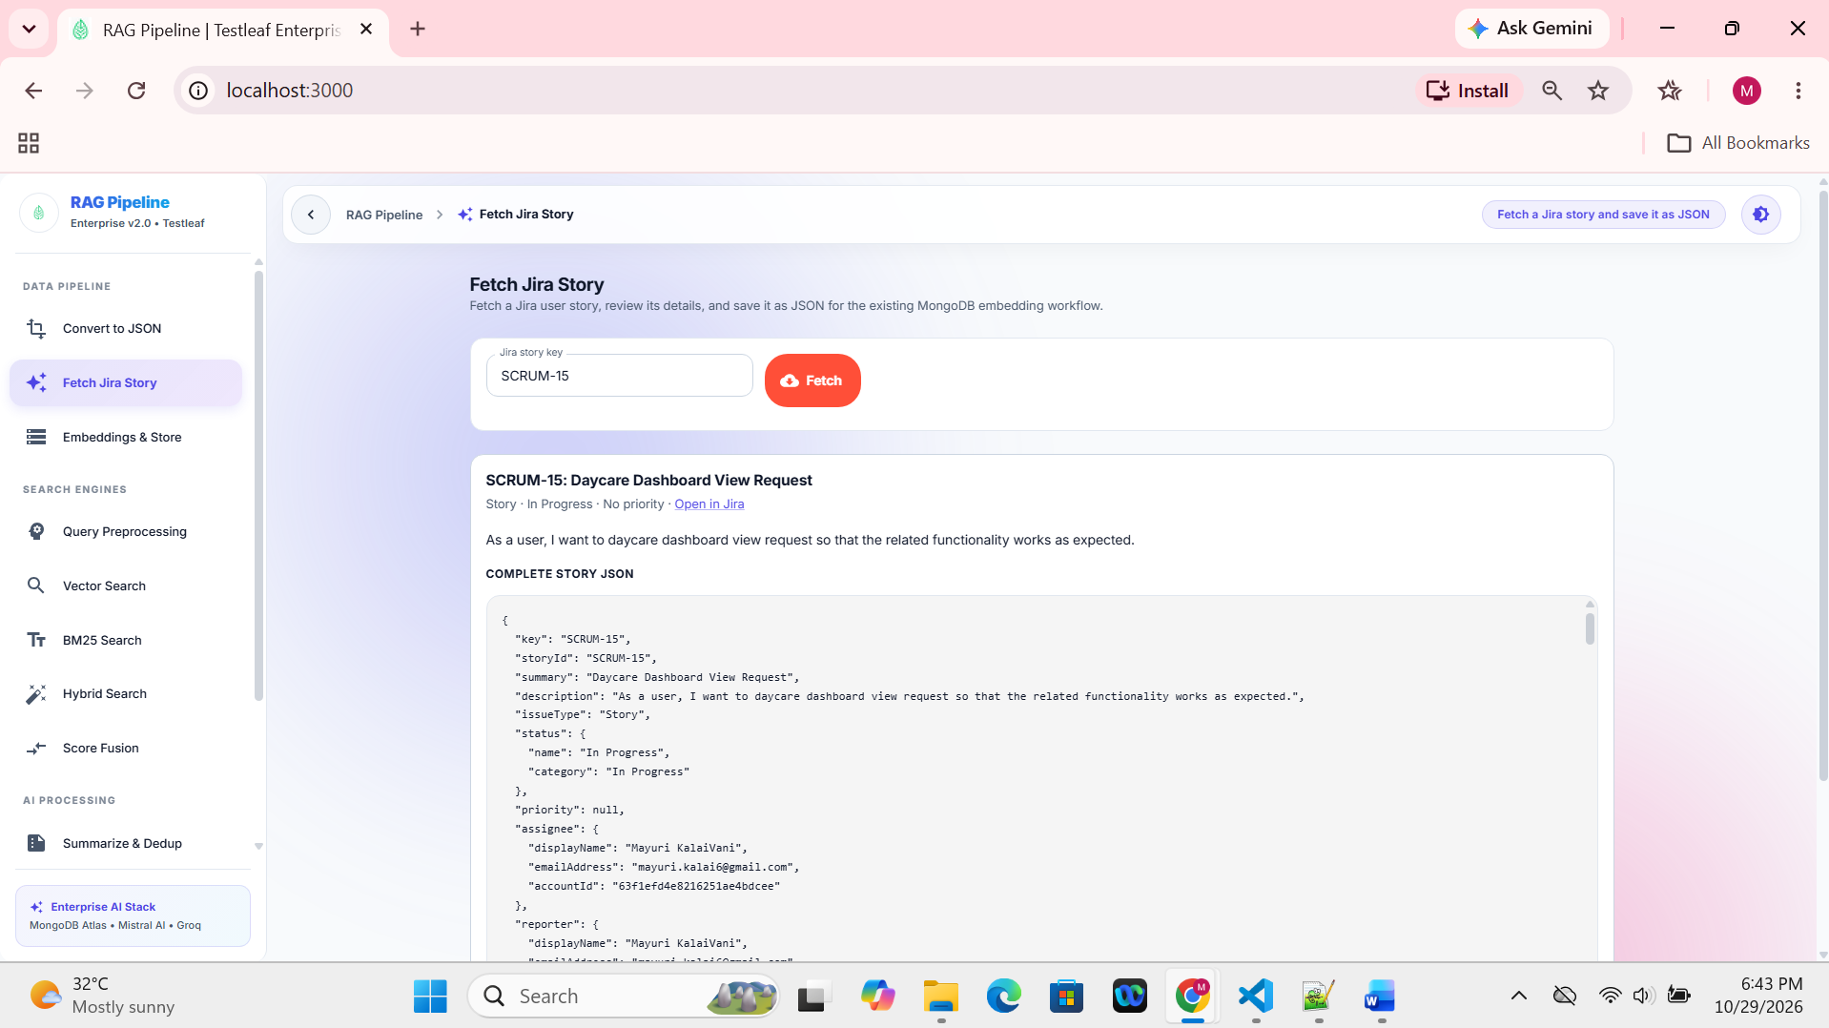

Retrieved Userstory stored in the Userstory JSON list:
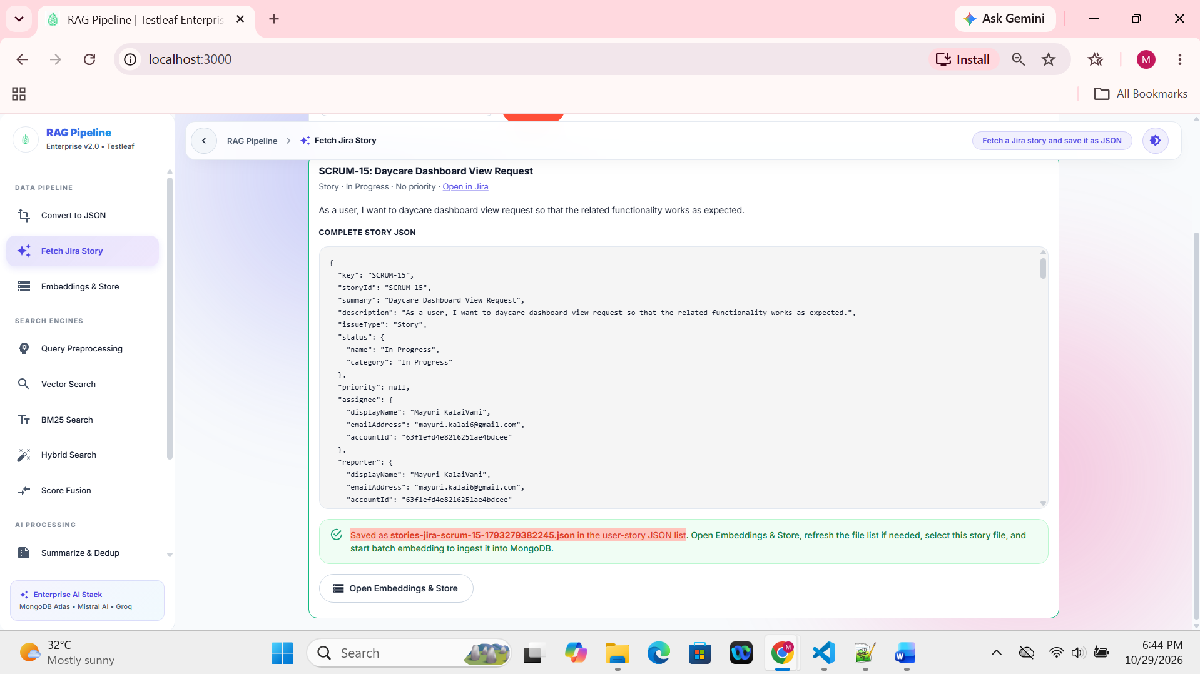
Userstory file listed under Available files:
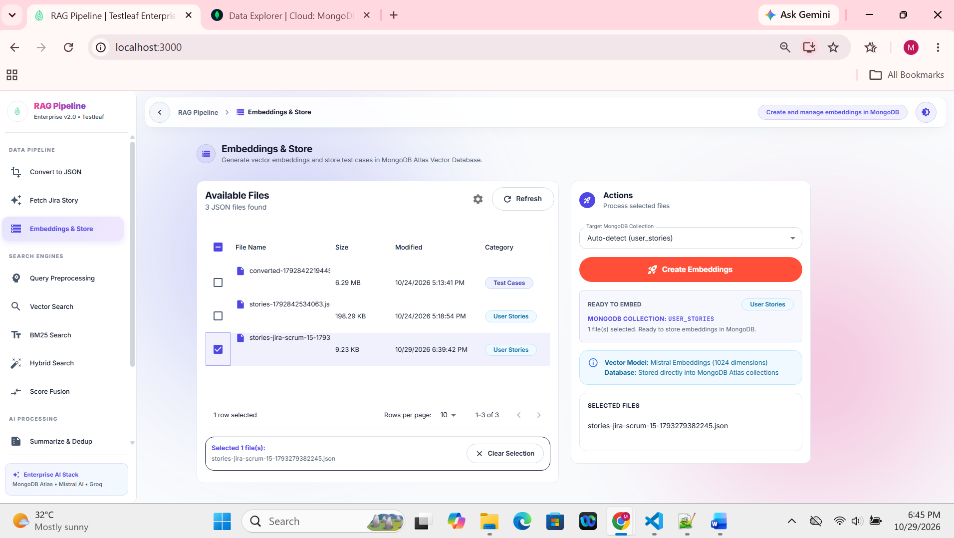

Userstory ingestion processed:
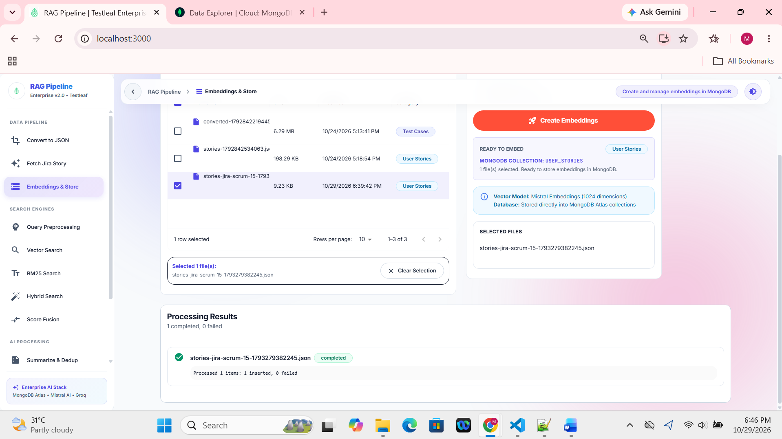

Jira Userstory ingested in MongoDB:
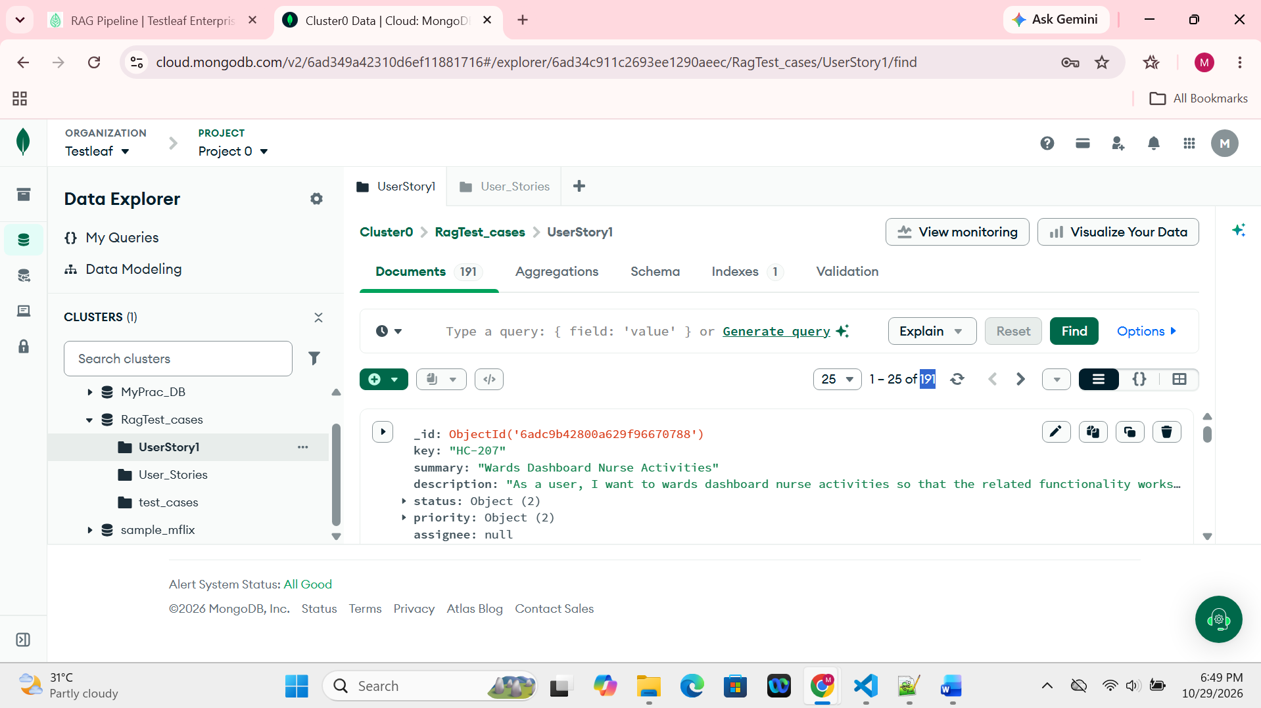
Negative input: Invalid UserStory Key returns error message:
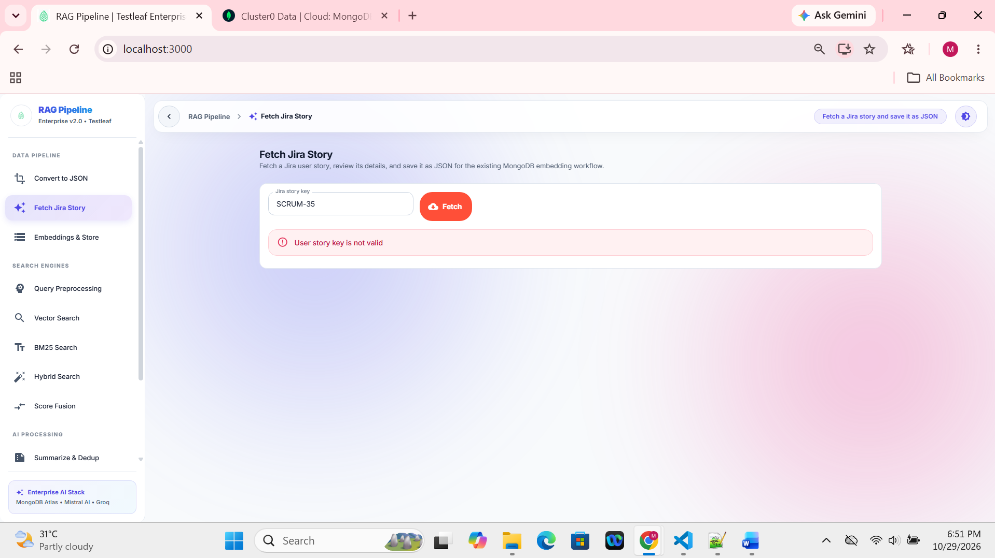

Testcases generated for the fetched Jira Userstory:

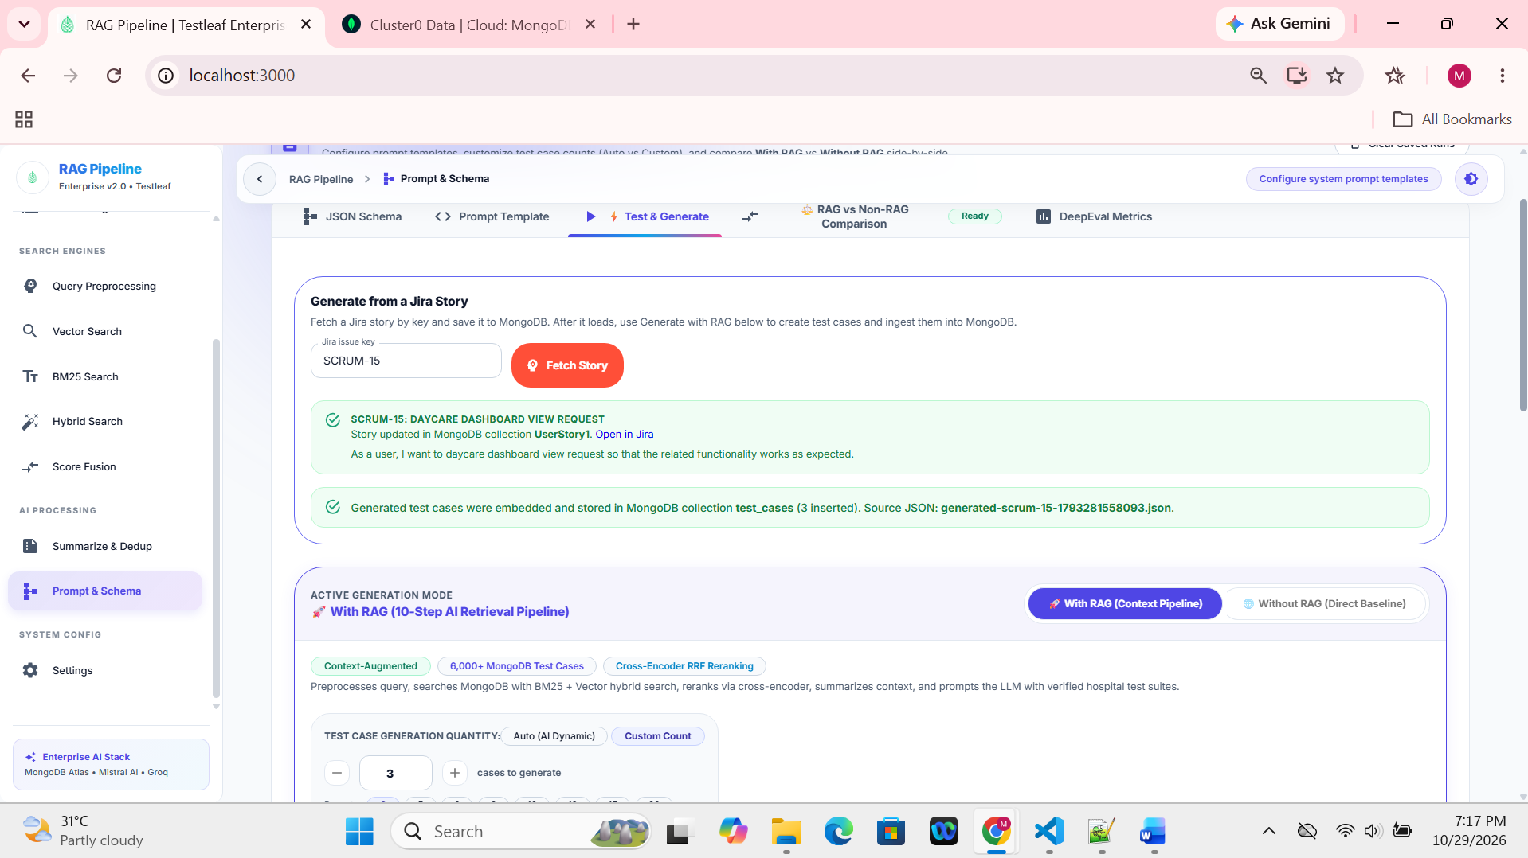
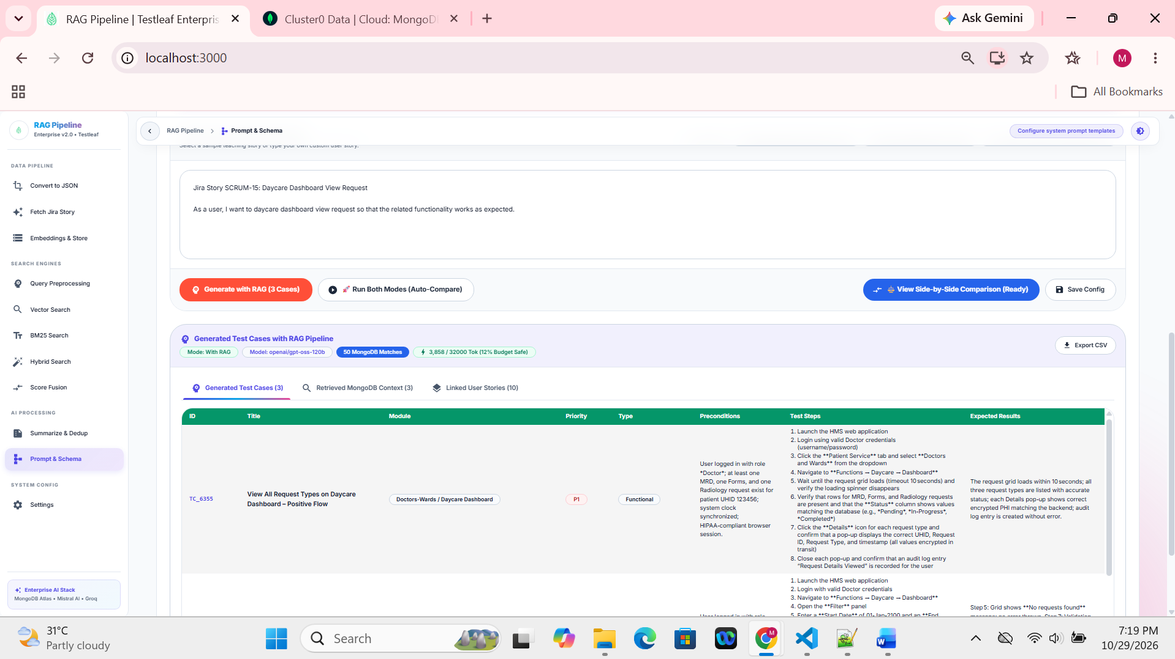

Vector Search Performed:
